Study Guide for Exam
Map Skills review
- Describe the lines of latitude.
  - Run _________ to ____________
  - Measure ______________ to ______________
- Describe the lines of longitude.
  - Run _________ to ____________
  - Measure ______________ to ______________
- What is a map key?
- What is a map scale?
- Using the map below, list the continents and the oceans.
1. A.
2. B.
3. C.
4. D.
5. E.
F.
G.
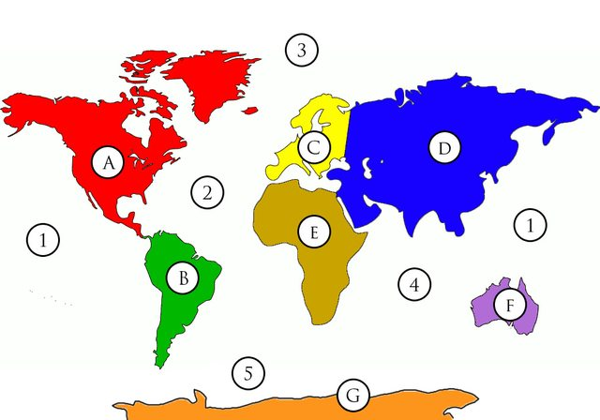

- 0° Latitude is called the _____________________.
- 0° Longitude is called the _____________________.
- The equator splits the earth into _____________ and ________________ Hemispheres.
- The prime meridian splits the earth into _____________ and ________________ Hemispheres.
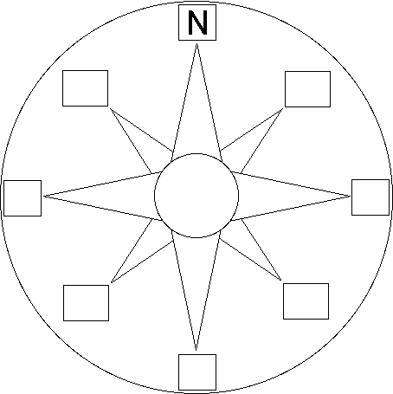
- Draw and label a compass rose.

- What are the cardinal directions?
- What are the intermediate directions?
- What does a physical map show?
- What does a political map show?
- What is the century for:
  - 1299: b. 1584
- What is the year for:
- 15th century: b. 10th century

Government review
Unitary Federal Confederation
- Local governments (alliances) have the most power. ___________________
- The central government has the most power. _____________________
- The central and local governments share the power. __________________
Absolute Monarchy Dictatorship Republic Direct Democracy
Presidential Democracy Parliamentary Democracy Constitutional Monarchy
- People elect representatives. __________________
- One person controls and gained the power through inheritance. ___________________
- The citizens elect the legislative but not the executive branch. It is led by a prime minister. _______________
- A king or queen’s power is limited by the people. _____________________
- One person controls and gained the power through the use of force. ___________________
- All people (citizens) can vote. ___________________
- The citizens elect both the legislative and executive branch and headed by a president. _______________

Autocracy Oligarchy Democracy
- One group controls the government. ________________
- The people show their power through voting. ________________
- One person controls the government. ________________
Fill in the blanks
One central government in charge

One person in charge One group in charge

Person Inherits Power Person takes power

Central government shares power with local government

All citizens vote Citizens elect King or Queen for everything representatives has limited power

Citizens elect Legislature Citizens elect Legislature and executive branch Legislature selects executive branch

Economy review
- Define economics.
- What is barter?

Consumer Producer Distributor Entrepreneur

- The person who makes or grows a good or performs a service ______________
- The person who comes up with a product or service, or a better way to produce one. He takes the risk. ____________________
- The person who sells or gives out a product or service ___________________
- The person who buys a good or a service _____________________

- What is currency?
- What is currency exchange?

- Label the parts of the economic continuum.

Traditional Market Mixed Command
- People can choose a price they want to charge within the limits set by the government. ________________
- People have passed down their knowledge through generations. ______________
- The government makes all decisions. _____________________
- People can choose any price they want to charge. The government is not involved in any way. _________________________

- What are the 3 trade barriers?

Embargo Sanctions Quota Tariffs

- A tax on imports _____________________
- A limited or fixed number or amount _______________________
- An official ban on trade with a particular country ________________
- A threatened penalty for disobeying a law or rule _____________________

- Define GDP.

- Describe the differences between a developing and a developed country.

Capital Goods Natural Resources Human Resources
- The employees or anything that directly affects the employees; such as training _________________________
- Natural materials used in productions; such as water, trees, coal, gas, land, etc. _________________________
- Man-made resources used in production; such as money, building, tools, etc. __________________________

Religion review

- Define monotheism and polytheism.

- Compare and contrast Judaism, Christianity, and Islam.
 | Judaism | Christianity | Islam
Follower is called
Place of worship
Sacred (Holy) Text
Leader of worshippers
Sabbath (Holy) Day

