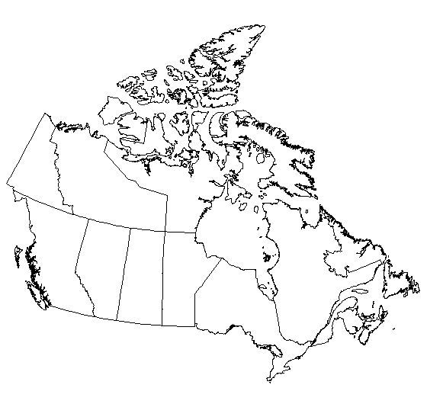

**Things to label:**

**Color each area a different color.**

* British Columbia
  + Vancouver
* Alberta
  + Calgary
* Saskatchewan
* Manitoba
* Ontario
  + Toronto
  + Ottawa
* Quebec
  + Montreal
* Nova Scotia
* New Brunswick
* Newfoundland and Labrador
* Prince Edward Island
* Yukon Territory
* Northwest Territory
* Nunavut

**Bordering Country:**

* United States

**Bordering Waters: Color Blue**

* Pacific Ocean
* Atlantic ocean
* Arctic Ocean
* Baffin Bay
* Hudson bay
* St Lawrence River

**Draw in the Rocky Mountains and the Great Lakes**