Test Review Name: ____________________

Define:
- Absolute Location – exact location
- Relative Location – close to, near, about
- Scale - distance
- Key/Legend – explain symbols
- Physical Map – show physical features
- Political Map – show boundaries and borders
- Hemisphere – half a sphere
- Century – 100 years
- Equator – 0 degrees latitude, separates the earth into Northern and Southern Hemisphere
- Prime Meridian – 0 degrees longitude, separates the earth into Eastern and Western Hemisphere
- Latitude – lines that run east to west but measure north to south
- Longitude – lines that run north to south but measure east to west
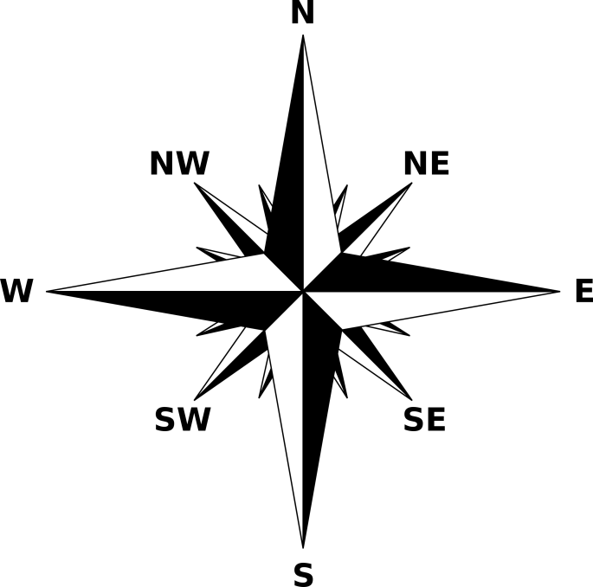
- Draw and Label all parts of a compass rose.

Latitude and Longitude Review

.

MAP A MAP B
Identify whether the statements below are true or false.
__True___ 14. The lines on Map A would be used to measure latitude.
__False___ 15. The lines on Map B would be used to measure latitude.
__True___ 16. Latitude lines measures north or south.
__False___ 17. The Prime Meridian is a latitude line.
__False___ 18. The 0°longitude is the equator.
_True____ 19. The prime meridian separates the earth into the eastern and western hemispheres.

Fill the Blank:
- What century is the year 1776? ____________18th__________________.
- What century is the year 1192? _______12th_______________________.
- What century is the year 210? __________3rd____________________.

See other pages for further review.

